Project Design Phase-II
Data Flow Diagram & User Stories

Date | 31 January 2025
Team ID
Team Members | Navyasri Meruga (Team Lead), Megha Sai Vardhan Chodavarapu, Mohammad Nasreen, Santosh Kakani, Gudavalli Sumanth
Project Name | India's Agricultural Crop Production Analysis (1997–2021)
Maximum Marks | 4 Marks

Data Flow Diagrams:
A Data Flow Diagram (DFD) is a traditional visual representation of the information flows within a system. A neat and clear DFD can depict the right amount of the system requirement graphically. It shows how data enters and leaves the system, what changes the information, and where data is stored.
Example: DFD Level 0 (Industry Standard)
Example: (Simplified)
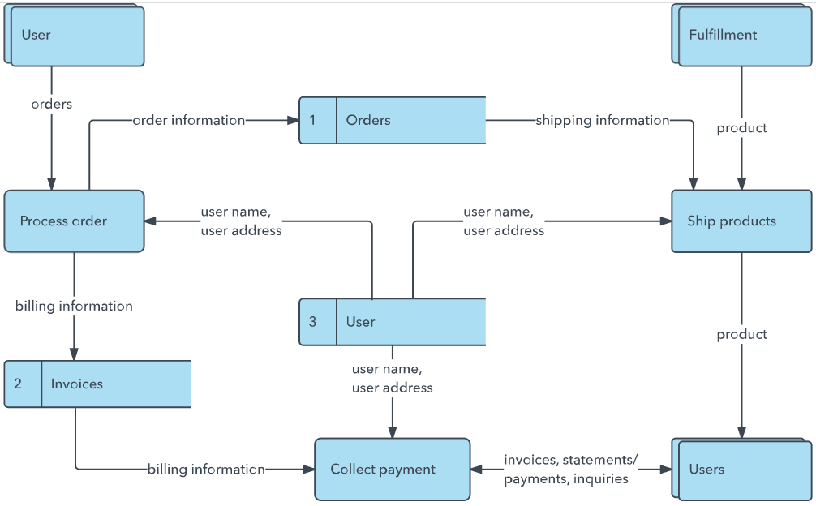


User Stories
Use the below template to list all the user stories for the product.
User Type | Functional Requirement (Epic) | User Story Number | User Story / Task | Acceptance criteria | Priority | Release
Farmer (Dashboard user) | Filter Data | USN-1 | As a farmer, I can filter the dashboard by state, crop, season and year range. | Filters update all charts and KPIs instantly | High | Sprint-4
 |  | USN-2 | As a farmer, I can view the best-performing crops for my state and season. | I can see a ranked list of crops by yield | High | Sprint-4
 |  | USN-3 | As a farmer, I can view seasonal production trend charts. | Chart updates based on selected filters | Medium | Sprint-3
 |  | USN-4 | As a farmer, I can view the yearly production trend for my region. |  | Medium | Sprint-3
Policy Analyst | Identify Weak Areas | USN-5 | As a policy analyst, I can view the lowest-yield states and weak state-crop pairs. | Table lists bottom N states/crops by yield | High | Sprint-4
 | Dashboard
Investor
Data Engineer
Administrator

